English  Writing - Poetry based on -’The  Dreadful Menace’  Shackleton’s journey - diary writing  Shackleton’s journey - biography of Ernest Shackleton  Incorporating the Year 6 GPS curriculum  Guided Reading  Shackleton’s journey by William Grill  Extracts related to exploration of Antarctica  Spelling - RWI scheme  Handwriting | Maths  Place value  - Numbers to 1,000,000  - Numbers to 10,000,000  - Read and write numbers to 10,000,000  - Powers of 10  - Number line to 10,000,000  - Compare and order integers  - Round any integer  - Negative numbers  Addition and subtraction  - Add and subtract integers  - Common factors  - Common multiples  - Rules of divisibility  - Primes to 100  - Square and cube numbers  - Multiply up to a 4 digit number by a 2 digit number  - Solve problems with multiplication  - Short division  - Division using factors  - Introduction to long division  - Long division with remainders  - Solve problems with division  - Solve multi-step problems  - Order of operations  - Mental calculations and estimation | Science  Living things and their habitats  To group and sort animals based on their observable features.  To know some of the features of invertebrates and to be able to identify them in school grounds.  To explain and understand micro-organisms.  To know how to use a microscope.  To understand how different organisms can be classified.
RE  Why does religion look different around the world?  - How do some religions believe in the same God?  - How might a Jewish person observe Shabbat?  - Why is Friday night dinner different?  - What can a head covering tell us about identity?  - Why might someone want to cover their hair? | Year 6  Autumn term 1  Shackleton’s exploration of Antarctica  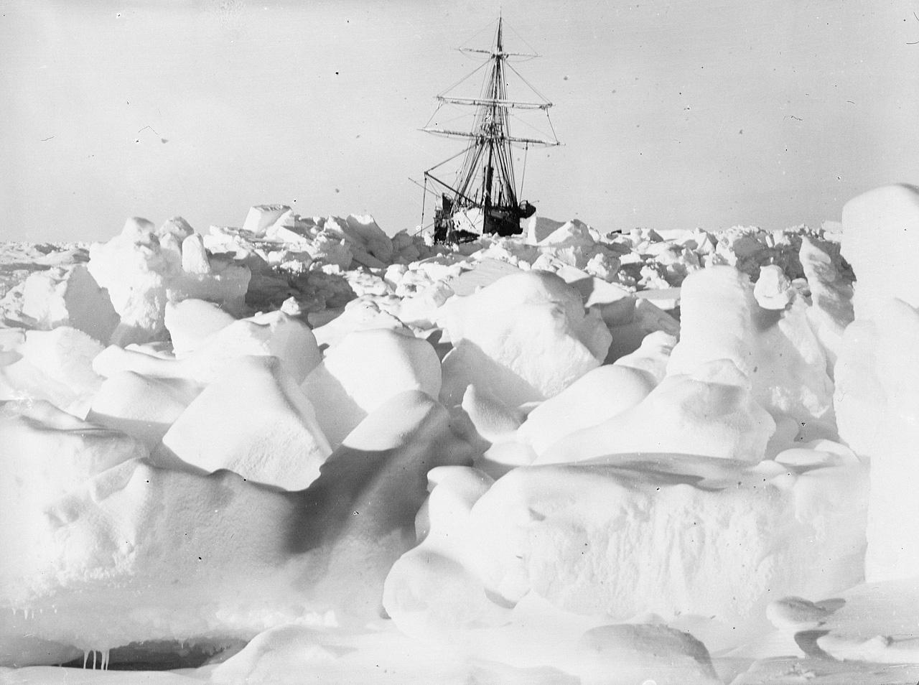 | PSHE  ‘Me and my relationships’  Working together, negotiating, solving friendship problems, assertiveness skills, behaving appropriately.
Computing  Computing systems and networks - communication and collaboration  - Internet addresses  - Data packets  - Working together  - Shared working  - How we communicate  - Communicating responsibly  DT  Design and make a beanie hat (for a teddy) which includes a light. | History  Arctic explorers - Why and how did Ernest Shackleton travel to Antarctiac? (the lives of significant individuals in the past who have contributed to national and international achievements).  To use images as primary sources to make inferences about a significant person in history  To know and sequence the events of Shackleton’s expeditions  Geography  Where is Antarctica?  What is the landscape like?  What was the route taken by Shackleton on his last expedition to the South Pole? | Music  Compositions inspired by musicians  PE/Games  Tag rugby  Football

