English  As readers and writers we:  - We will read The Boy at the Back of the Class by Onjali Q Rauf. This will help us to develop our vocabulary to use in our writing.  - We will be reading this book as part of our class guided reading sessions where we will build upon skills that enable us to infer from different text types.  - We will begin the term by writing an information text about an element of Victorian history.  - We will then write a diary extract which will be performed aloud as a monologue. | Maths  As mathematicians, we will:  Fractions, decimals and percentages:  - represent thousandths as fractions and decimals.  - Compare and order decimals.  - Round decimals to the nearest whole number.  - Round decimals to 1dp.  - Understand percentages.  - Show percentages as fractions.  - Show percentages as decimals.  - Show equivalent fractions, decimals and percentages.  Perimeter and area:  - Calculate the perimeter of rectangles, rectilinear shapes and polygons.  - Calculate the area of rectangles of compound shapes.  - Estimate area. | Science  As Scientists we shall be learning about materials and their properties.  This half term we will continue to:  - Understand what a chemical reaction is and how we can tell that one has taken place.  - Know the difference between a soluble and insoluble material.  - Investigate how the amount of substance affects the time taken/number of stirs taken to dissolve it.
History  As Historians we will continue to explore the Victorians. We will be investigating the questions-  How did daily life change over the reign of Queen Victoria?  Was it really better to be rich than poor as a child in Victorian times?  How did the child of an American slave make white inventor Thomas Edison famous? | 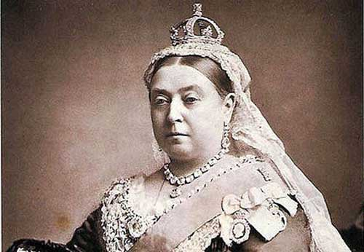  The Victorians  Year 5 Summer 1 2026 | P.S.H.E.  In PSHE this term, we are learning about ‘Being my Best.’  Please find activities to support with these topics, which you can do from home:  https://www.coramlifeeducation.org.uk/family-scarf/scarf-at-home/being-my-best  R.E. In RE this term, we will be answering the question-  How significant is it for Christians to believe God intended Jesus to die?
Geography  As Geographers we will:  - Locate key rivers in the UK and explain the use of rivers during the Victorian Era.  - Understand the importance of canals during the Victorian era.  - Locate key cities.  - Compare maps to find out how railways developed.  - Use maps to describe how the British landscapes changed. | DT  As Design Technologists, we will be designing and making our own Victorian fairground rides. This will be followed by an evaluation.  Music  Music lessons are taught by XYZ. | Computing  As computer scientists, we shall be learning about systems and networks.  PE  In PE, we will be enhancing our skills in cricket and tennis.

