English  As readers and writers we:  - We will read Holes by Louis Sacher as our class shared reading. This will help us develop our vocabulary to use in our writing.  - We will be reading this book as part of our class guided reading sessions where we will build upon skills that enable us to infer from different text types, specifically looking at how to link back to the text to support our answers.  - We will be writing to entertain by writing a poem based on the poem called ‘Wonderfully different, Beautifully the same’ by Joseph Coelho.  - We will be writing to entertain by writing a letter from the perspective of the main character in Holes, Stanley Yelnats.  - We will be writing to persuade, by writing a letter to Mrs Myers about what changes we would like to make to the school uniform policy. | Maths  As mathematicians, we will:  Multiplication and Division  - Identify multiples of a number and notice if times tables have common multiples  - Identify the Factors/common factors  - Learn that prime numbers are numbers with only two factors  - Learn that square numbers are a result of multiplying a number by itself  - Learnt that a cube numbers is the result of multiplying a number by itself and then by itself again  - Revisit multiplying by 10, 100 and learn how to multiply by 1,000  Fractions  - Find fractions equivalent to a unit fraction  - Find fractions equivalent to a non-unit fraction  - Recognise equivalent fractions  - Convert improper fractions to mixed numbers  - Convert mixed numbers to improper fractions  - Compare fractions less than 1  - Order fractions less than 1  - Compare and order fractions greater than 1 | Science  As Scientists we shall be continuing to learn about forces. This includes  - Explain that unsupported objects fall towards the Earth because of the force of gravity acting between the Earth and the falling object  - Identify the effects of air resistance, water resistance and friction, that act between moving surfaces  - Recognise that some mechanisms, including levers, pulleys and gears, allow a smaller force to have a greater effect.
History  As Historians we will be exploring the Ancient Greeks. We will be finding out about:  - The structure of Ancient Greece and its society.  - Similarities and differences between Athens and Sparta.  - Persian and Greek warfare.  - The evolution of democracy in Ancient Greece.  - Similarities and differences between modern democracy.  Geography  As Geographers we will be learning about Greece. We will be locating Greece on the map, thinking about why it is a popular place to visit and how it has changed over time. | 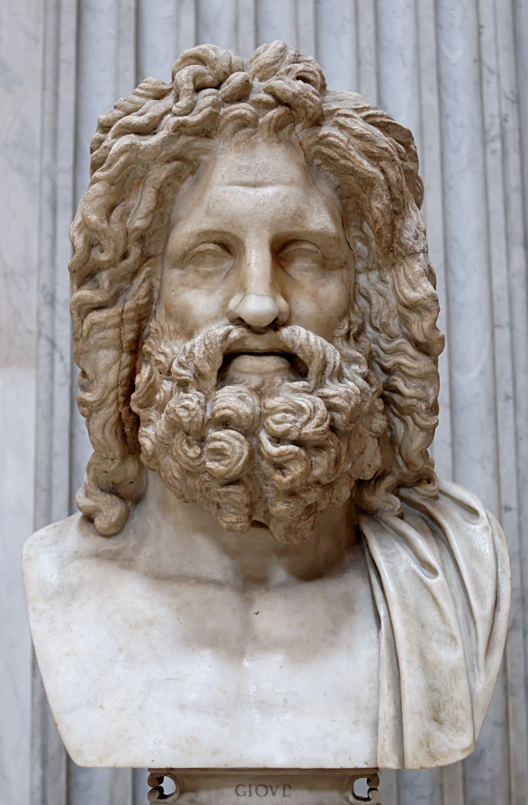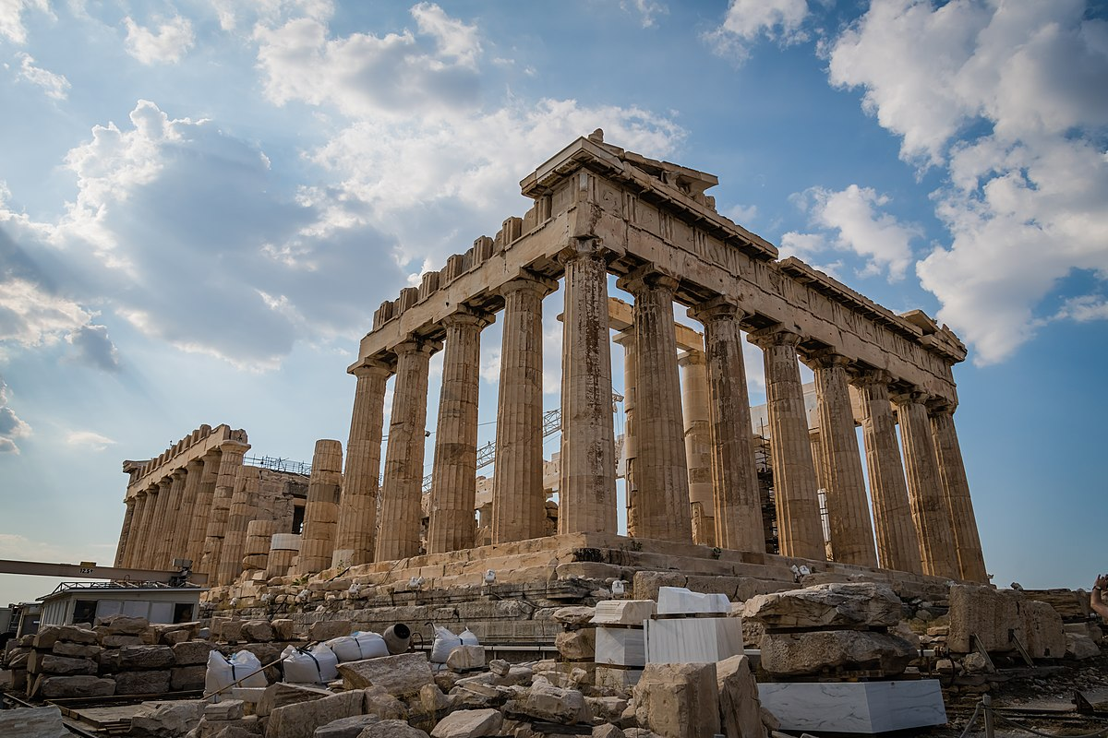  The Ancient Greeks  Year 5 Autumn 2 2025 | P.S.H.E.  We will be looking at ‘Valuing Difference’. This will have us looking at friendships and how to be a good friend.  R.E.  We will be looking at the question ‘Why doesn’t Christianity always look the same?’. We will be looking at the different denominations for Christianity and how they each interpret the bible.
PE  In PE, we will be enhancing our skills in hockey and basket ball.  Both of our PE sessions each week will be taught by S4A. | DT:  In DT we are going to design and make an Archimedes screw to transport cereal from one container to another | Computing  In computing, we will be looking at creating our own videos. We will learn to record using different techniques (talking head, panning and close ups).  We will then plan, record and edit our own video.

