English  As readers and writers we:  - Will read Brightstorm by Vashti Hardy as our class shared reading. This will help us develop our vocabulary to use in our writing.  - Will be using this text in our whole class reading sessions to explore our reading skills that we have been learning.  - Will be writing a newspaper article, to inform, about the death of Ernest Brightstorm.  - Will be writing to entertain with a diary written from the perspective of The Lighthouse Keeper.  - Will be writing to persuade travellers to take a trip to see the Northern or Southern Lights in an information leaflet. | Maths  As mathematicians, we will:  Addition and Subtraction  - Subtracting numbers with up to 4 digits using the formal written methods of column addition and subtraction.  - Estimate and use inverse operations to check answers to a calculation  - Solve addition and subtraction two-step problems, deciding which operations and methods to use and why.  Area:  - Understand what the area of a shape is.  - Calculate area.  - Compare the area of different shapes  Multiplication and Division:  - Recall multiplication and division facts for multiplication tables up to 12 × 12  - Use place value, known and derived facts to multiply and divide mentally, including: multiplying by 0 and 1; dividing by 1; multiplying together three numbers  - Recognise and use factor pairs and commutativity in mental calculations  - Multiply two-digit and three-digit numbers by a one-digit number using formal written layout  - Solve problems involving multiplying and adding. | Science  As Scientists we shall be learning all about light.  This half term we will:  - Recognise that we need light in order to see things, and that dark is the absence of light.  - Notice that light is reflected from surfaces.  - Recognise that light from the sun can be dangerous and that there are ways to protect their eyes.  - Recognise that shadows are formed when the light from a light source is blocked by an opaque object.  - Find patterns in the way that the size of shadows change.
Art  As Artists, we will be learning how to tell a story through drawings.  We are going to explore a range of different artists and learn how to apply some of their skills to our own sketches. We will also discuss and discover how to sequence our work to tell an engaging story through pictures. | 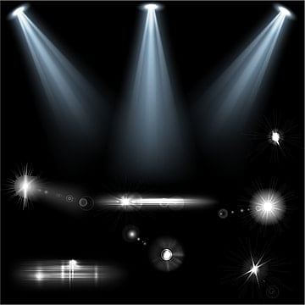  Lights and Lenses  Year 4 Autumn 2 2025 | P.S.H.E.  In PSHE this term, we are learning about ‘Valuing Difference’’.  Here is the link for you to access activities at home:https://www.coramlifeeducation.org.uk/family-scarf/scarf-at-home/valuing-difference  R.E.  Our key question that we will be exploring in RE this term is ‘What makes some texts sacred?’  We will explore the origins of religious texts and consider their value to some followers.
Geography  As Geographers we will be exploring the Northern and Southern Lights. We will look at key facts as well as locating the Northern and Southern Lights using atlas coordinates. | PE:  In PE this term, we will be building on our skills in football and hockey. | Computing  As computer scientists, we will be learning to create media through audio production.  We will learn how sound is created and used digitally by exploring microphones, speakers, and headphones.

