English  As readers and writers we:  - We will read How to Train Your Dragon by Cressida Cowell as our class shared reading. This will help us develop our vocabulary to use in our writing.  - We will also be exploring a variety of other texts throughout our whole class reading lessons.  - We will be writing to explain how the wishing machine works from ‘The Wishgranter’.  - We will be writing to entertain with a short adventure story using Arthur and the Golden Rope by Joe Todd Stanton.  - We will be writing to inform with a letter in response to one from Cressida Cowell. | Maths  As mathematicians, we will:  Place value  - Represent and partition numbers up to 1,000.  - Represent and partition numbers beyond 1,000.  - Flexibly partition numbers up to 10,000.  - Find 1, 10, 100 or 1,000 more and less than a number.  - Compare and order numbers up to 10,000.  - Round any number to the nearest 10, 100 or 1,000.  - Recognise and write numbers as Roman Numerals.  Addition and Subtraction  - Add and subtract 1s, 10s, 100s and 1,000s.  - Add two 4-digit numbers with and without exchanging.  - Subtract two 4-digit numbers with and without exchanging.  - Learn how to efficiently subtract.  - Estimate answers.  - To check our addition and subtraction | Science  As Scientists we shall be learning all about sound.  This half term we will:  - Identify how sounds are made, associating some of them with something vibrating.  - Recognise that vibrations from sounds travel through a medium to the ear.  - Find patterns between the pitch of a sound and features of the object that produced it.  - Find patterns between the volume of a sound and the strength of the vibrations that produced it.  - Recognise that sounds get fainter as the distance from the sound source increases.
History  As Historians we will be looking at the Battle of Edgehill and considering our key enquiry question:  What evidence, if any, is there that any battle took place at Edgehill?  We will explore how the battle has shaped the UK into the country that it is today. Our significant historical figures are Charles I and Oliver Cromwell. | 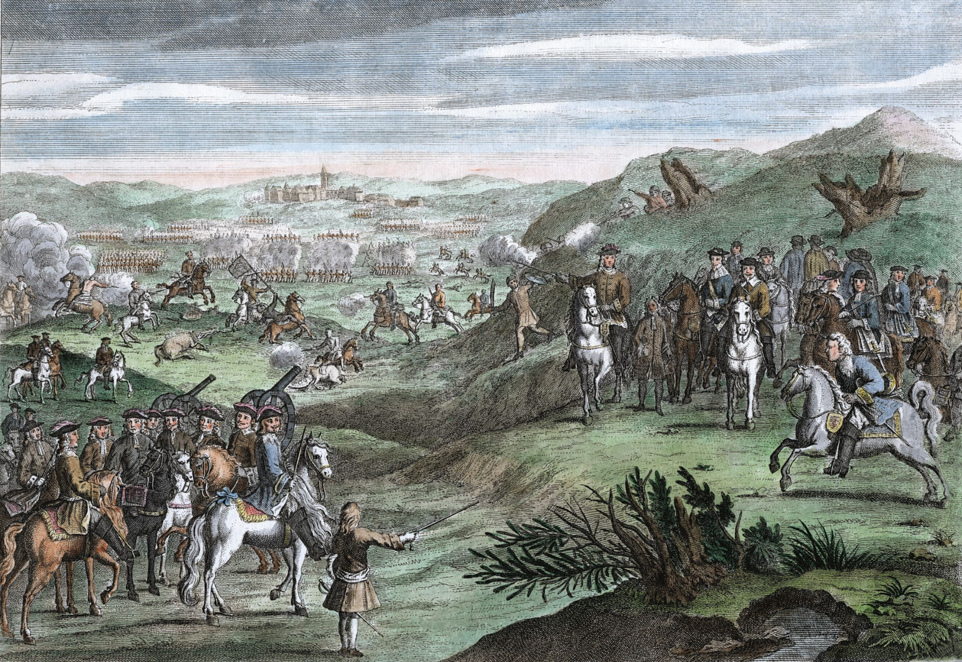  The Battle of Edgehill  Year 4 Autumn 1 2025 | P.S.H.E.  In PSHE this term, we are learning about ‘Me and My Relationships’.  Here is the link for you to access activities at home:https://www.coramlifeeducation.org.uk/family-scarf/scarf-at-home/me-and-my-relationships  R.E.  Our RE topic this term is ‘Are all religions equal?’ We will explore the origins of various religions, and children will discover geographical and historical connections among them.
Geography  As Geographers we will be considering the following key enquiry questions:  - How is the UK made up of counties, cities, towns and villages?  - Where is Edgehill? Why did the battle take place here?  - Are there other local battlefields?  To complete our enquiries we will use atlases, compass points, Ordnance Survey Maps and fieldwork to develop a greater understanding. | D.T/Art  As Designers we will be designing, making and evaluating a drum to engineer sound for a video clip of the enactment of the Battle of Edgehill.  Music  As musicians, our focus this term is ‘Instruments of the orchestra.’ We will understand what is meant by pitch, pulse and rhythm as well as the different instrument families in an orchestra. | Computing  As computer scientists, we will be learning about computing systems and networks. Children will explore how the internet and World Wide Web work, practice using online tools creatively, and develop skills to evaluate the reliability and ownership of online content.  PE  In PE this term, we will be developing our skills in Netball and Tag Rugby. One of these lessons will be delivered by S4A.

