English  As readers and writers we will:  - Read a range of extracts from texts and picture books with a volcanic theme, as well as some that relate to our science topic.  - Write a setting description of Pompeii.  - Write a report about volcanoes, based on the Disney video ‘Lava’.  - Follow Read Write inc. for our spelling.  - Learn the Year 3 SPaG objectives as part of our writing journeys. | Maths  As mathematicians, we will learn formal written methods of division, explore length and perimeter and begin to develop our understanding of fractions  Length and perimeter  Measure in m, cm and mm  Equivalent lengths  Compare, add and subtract lengths  Measure perimeter  Calculate perimeter  Fractions  Compare and order fractions  Understand non-unit fractions  Place fractions on a number line  Identify equivalent fractions | Science  As scientists we will be learning about plants  This half term we will:  - Identify parts of a plant and their functions  - Learn what plants need to survive  - Learn how changing conditions changes the health of a plant  - Dissect the parts of a flower and label them.  - Understand the process of plant reproduction
History  As historians, we willt:  - Learn about the eruptions of Mount Vesuvius and Krakatoa.  - Learn about the Indian Ocean Boxing Day Tsunami.  We will also explore the causes of these natural disasters and their impact on the surrounding areas. | Year 3 - Spring 2  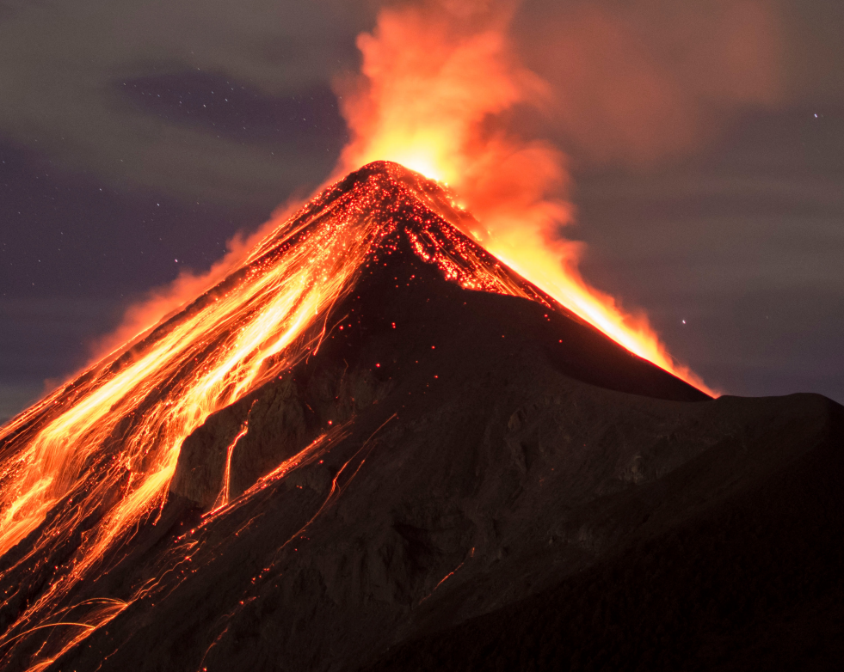  Natural Disasters | P.S.H.E.  In PSHE this term our theme is rights and respect.  R.E.  Our RE question this term is ‘Is scripture central to religion?’  French  In French we will be learning ‘Les instruments’.
Geography  As geographers, we will be learning about the causes of different natural disasters. We will:  - Find out about the layers of the Earth.  - Find out what causes earthquakes and volcanoes.  - Learn about Mount Vesuvius and Krakatoa.  - Understand the effects of natural disasters on the world. | DT  In DT, we will be applying our knowledge of different structures to try and make bridges. | Music  Our topic is ‘Instruments of the orchestra’  Computing  As computer scientists, we will be learning about branching databases and exploring data.  PE  S4A will teach us gymnastics.  We will also learn outdoor adventurous activities.

