English  As readers and writers we will:  - Read Oliver and the Seawigs and Escape from Pompeii.  - Read a range of extracts from texts and picture books with a Roman theme, as well as some that relate to our science topic.  - We will be following the RWI spelling scheme.  - Writing outcome one: poetry inspired by the Romans  - Writing outcome two: write to persuade – join Boudicca’s army  - Writing outcome three: story – retelling the story of Boudicca using speech | Maths  As mathematicians, we will learn how to:  - Share between equal groups and use arrays.  - Count in our 2s, 5s and 10s.  - Multiply and divide by 3.  - Multiply and divide by 4.  - Multiply and divide by 8.  - Complete reasoning questions related to multiplication.  - Make links between multiplication and division. | Science  As scientists we will be learning about states of matter  This half term we will:  - Learn that there are three states of matter; solid, liquid and gas  - Learn that all matter is made up of molecules.  - Learn how these molecules are different in solids, liquids and gases.  - Explore how matter can change from one state to another by heating.  - Explore how matter can change from one state to another by cooling.
History  As historians, we will find out about the Roman Empire and the invasion of Britain  This half term we will:  - Learn how the Romans were ruled  - Explore the effectiveness of the Roman army  - Sequence the Roman invasions of Britain  - Learn about Boudicca and the Celtic resistance  - Explore changes the Romans made to Britain | Year 3 - Spring 1  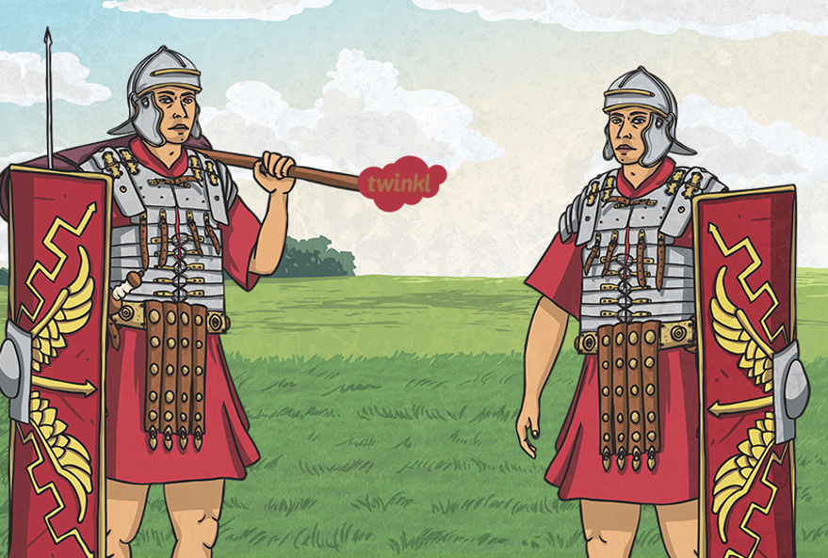  The Roman Invasion of Britain | P.S.H.E.  In PSHE this term our theme is keeping safe. You can access resources for this via the link below:  https://www.coramlifeeducation.org.uk/family-scarf/scarf-at-home/keeping-myself-safe  R.E.  Our RE question this term is “Where do our morals come from?”  French  In French we will be learning how to say different animal names.
Geography  As geographers, we will be learning about the Roman Empire  This half term we will:  - Learn why the Romans settled in Rome  - Understand the growth of the Empire  - Identify impacts of the Roman invasion on land use and human features | Art:  As artists, we will be looking at how we:  - Can combine art and craft, using painting and sewing to make art.  - Use media together, such as paint and thread, to build an image.  - Can transfer the skills from one medium, such as mark making in drawing, to another, like sewing.  - Can reinvent how materials are used to make art, rather than using them in traditional ways. | Music  We will be exploring classical composers such as Stravinsky and discovering how music is written on the bars.  PE  S4A will teach us basketball.  We will also learn dance.

