English  As readers and writers we will:  - Read ‘The Iron Man’ by Ted Hughes  - Writing a poem based on ‘The coming of the iron man’ by Brenda Williams  - Writing a character description of The Iron Man.  - Writing an explanation text based on ‘Girl and Robot.’  - Follow Read Write inc. for our spelling.  - Learn the Year 3 SPaG objectives as part of our writing journeys. | Maths  As mathematicians, we will learn about addition and subtraction as well as multiplication and division:  Addition and Subtraction  Subtract 1s across a 10 and 10s across a 100  Add and subtract 2 numbers with no exchange  Add and subtract 2 numbers across a 10  Add and subtract 2 numbers across a 100  Add two and three-digit numbers  Estimate answers  Check our calculations using inverse operations  Multiplication and division  Revise multiplication as equal groups  Revise division by grouping and sharing  Revise multiples of 2, 5 and 10  Learn the 3 times table and related division facts  Learn the 4 times table and related division facts  Learn the 8 times table and related division facts | Science  As scientists we shall be learning about friction and magnets. We will:  - Understand friction and why it is useful.  - Investigate how height and different surface materials can affect the speed of an object.  - Understand how magnets work.  - Investigate materials that are magnetic and those that are not.  - Learn about different types of magnets.
History  As historians, we will find out about the Roman Empire and the invasion of Britain  This half term we will:  - Learn how the Romans were ruled  - Explore the effectiveness of the Roman army  - Sequence the Roman invasions of Britain  - Learn about Boudicca and the Celtic resistance  - Explore changes the Romans made to Britain | Year 3 - Autumn 2  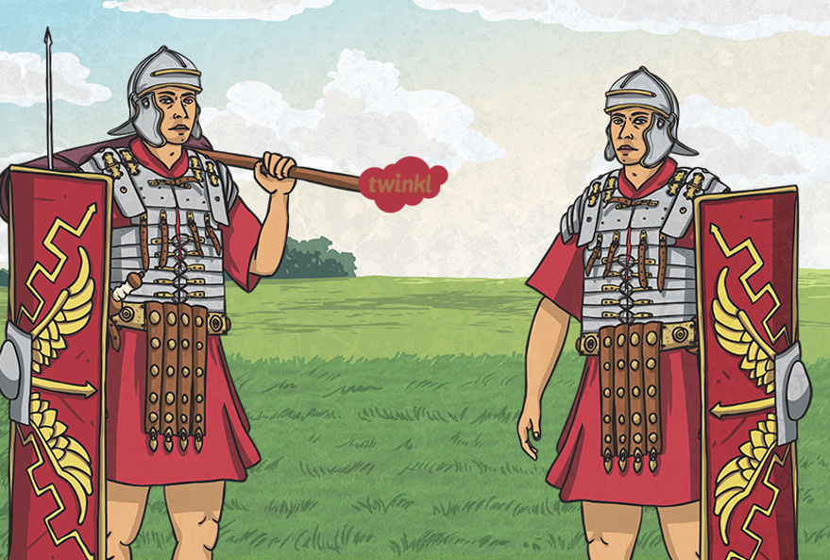  The Roman Invasion of Britain | P.S.H.E.  In PSHE this term, we are learning about ‘Valuing difference.’  To learn more about this at home, follow this link:  https://www.coramlifeeducation.org.uk/family-scarf/scarf-at-home/valuing-difference  R.E.  Our RE question this term is ‘Has Christmas lost its true meaning?’  French  In French we will be learning ‘Les Formes’ - shapes!
Geography  As geographers, we will be learning about the Roman Empire  This half term we will:  - Learn why the Romans settled in Rome  - Understand the growth of the Empire  - Identify impacts of the Roman invasion on land use and human features | DT:  As design technologists, we will:  - Learn about foods from the Iron age and talk about the impact of seasonality.  - Make Bannock Bread.  - Evaluate our Bannock bread and make suggestions for improvements. | Music  We will be continuing with our unit on Rhythm and pulse to help us learn how to read music.  We will then be looking at compositions inspired by Stravinsky.  P.E.  S4A will teach us football and hockey.

