English  As readers and writers:  - We will read Stone Age Boy  - We will read The Wild Way Home  - We will read a range of extracts from texts and picture books with a Stone Age theme.  - We will be writing a first person narrative based on a short film called Right of Passage  - We will be writing an adventure story based on Stone Age Boy  - We will be writing a persuasive leaflet about living in a Stone Age village  - We will follow RWI for our spelling  - We will incorporate the Year 3 SPaG objectives in our writing journeys | Maths  As mathematicians, we will learn about place value and addition and subtraction:  Place value  Learn to represent and partition numbers to 100  Learn to represent and partition numbers to 1000  Compare and order numbers to 1000  Find 1, 10 and 100 more or less  Addition and Subtraction  Add and subtract 1s, 10s and 100s  Add and subtract two numbers with no exchange  Add and subtract 2 numbers across a 10  Add and subtract 2 numbers across a 100  Add two and three-digit numbers | Science  As scientists we shall be learning all about rocks and soils  This half term we will:  - Discover where rocks are found and how they are used in the local environment.  - Find out how to test the hardness and permeability of rocks.  - Explain how different types of rocks are formed.  - Learn how fossils are made.  - Compare rocks based on their properties.
History  As historians we will explore The Stone Age, The Bronze Age and The Iron Age:  This half term we will:  - Explore the chronology of prehistoric Britain  - Learn about the different periods of the Stone Age, looking at similarities and differences  - Use artefacts to make inferences  - Understand what life was like in a Neolithic settlement | Year 3 - Autumn 1  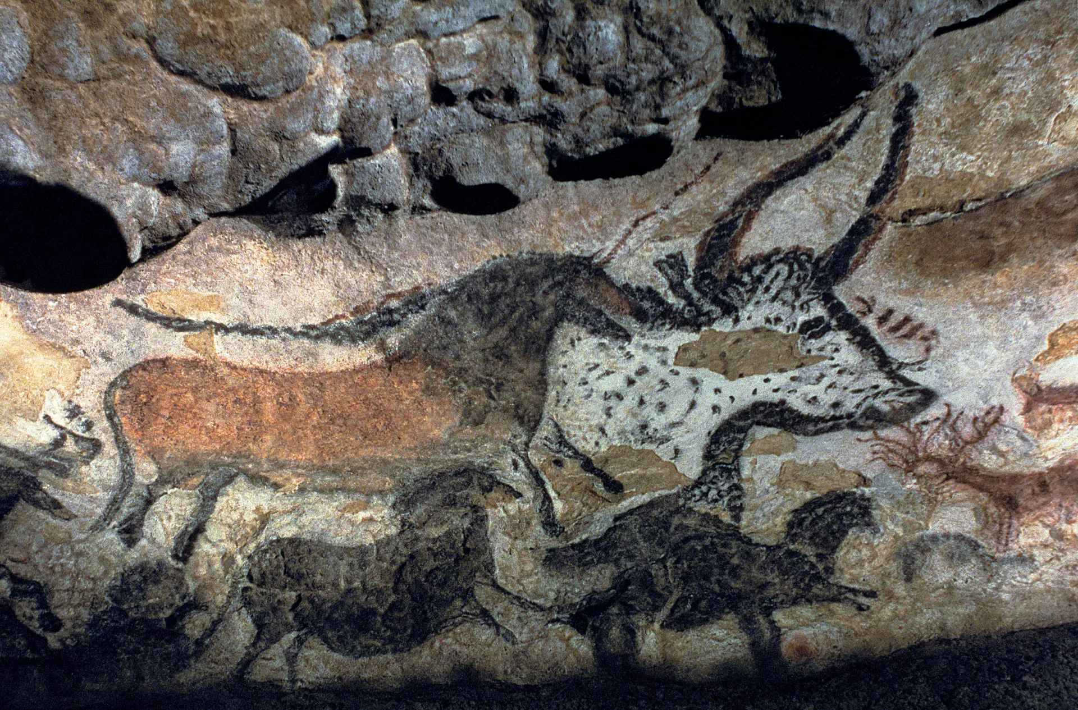  The Stone Age to the Iron Age | P.S.H.E.  In PSHE this term, we are learning about ‘Me and My Relationships’.  https://www.coramlifeeducation.org.uk/family-scarf/scarf-at-home/me-and-my-relationships  R.E.  Our RE question this term is ‘What makes us human?’  We will be exploring the following within this:  - What is special about being human?  - What is a soul and do we all have one?  - What do some people think makes us human?  - What is spirituality?  - What do some Buddhists do to focus on their inner self?  - Does anyone know what makes us human?
Geography  As geographers, we will:  - Look at different settlements from The Stone, Bronze and Iron Ages  - Locate Stonehenge and identify why it is a human feature  - Locate Skara Brae and explore how the land was used | Art:  As artists, we will:  - Explore the work of Laura McKendry and Edgar Degas  - Learn how to use charcoal  - Explore how cave people made art  - Understand how to use charcoal to create drawings based on a range of stimuli  - Reflect on and evaluate our work | Music  In our music lessons this term, our topic is ‘Instruments of the Orchestra’.  P.E.  We will be learning how to play both handball and netball.

