English  As readers and writers we will:  - Read Einstein the penguin by Lona Rangeley  - Write a report about an arctic animal  - Write a story based on ‘The Snowman’ by Raymond Briggs  - Write a character description using ‘The Bear and Hare’ Christmas advert | Maths  As mathematicians, we will continue to learn about addition and subtraction and shape.  Addition and Subtraction  - Part Whole Models  - Writing number sentences  - Number bonds to and within 10  - Addition  - Addition word problems  - Subtraction - finding parts  - Subtraction - take away/cross out  - Subtraction on a number line  - Add or subtract 1 or 2  Shape  - Recognise and name 3D shapes  - Sort 3D shapes  - Recognise and name 2D shapes  - Sort 2D shapes  - Patterns with 2D and 3D shapes | Science  As scientists we will continue learning about materials, their properties and their uses  This half term we will:  - Explore the features of mammals  - Explore the features of birds  - Explore the features of reptiles  - Explore the features of amphibians  - Compare groups of animals  - Group animals according to their features  - Explain why animals have their physical features (adaptation)  - Identify seasonal changes
History  As historians:  This half term we will:  - Explore who Robert Peary is  - Learn who visited the North Pole first  - Compare modern day explorers to ones in the past | Year 1 - Autumn 2  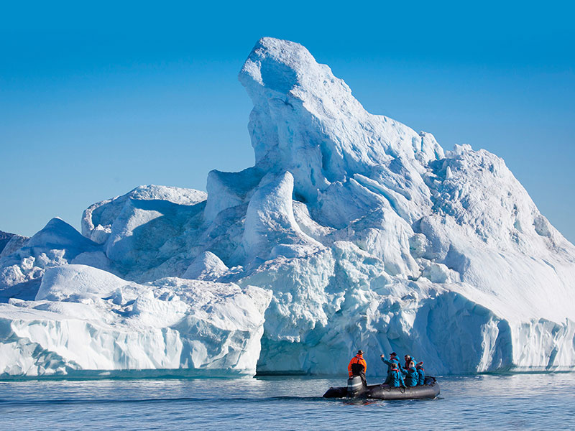  Arctic explorers | P.S.H.E.  In PSHE this term, we are focusing on valuing differences.  R.E.  Our Key Question in RE is:  ‘What do some people think God looks like?’  P.E.  We will continue to be taught P.E. by S4A.  We will be focusing on ball skills and fitness.
Geography  As geographers we will:  - Name and locate the seven continents  - Name and locate the five oceans  - Locate the Arctic and its position in our world  - Understand the climate of the Arctic  - Explore the way of life in the Inuit community | Art  As artists we will be:  - Discovering that artists find inspiration for artwork from their environment.  - Exploring the environment and collecting things that inspire us.  - Exploring different drawing exercises to record the things we have collected.  - To use a range of materials to create lots of varied mark making drawings of natural objects around us. | Computing  As computer scientists we will be continuing to practice logging on and off the chromebooks. We will be developing nativaging DoorwayOnline and our mouse skills.

