English  As Year 1 readers and writers we will:  - Write a character description using the text ‘The Bog Baby’.  - Write a story using the text ‘The Bog Baby’ as a stimulus.  - Write instructions using the video ‘A Cloudy Lesson’.  - Write a setting description using the wordless picture book ‘Willow’.  - Read a range of books related to our topic and answer simple questions about what we have read.  - Continue daily reading through our phonics program ‘Read, Write, Inc’.  Please listen to your child read their phonics books five times a week and encourage them to watch the phonics videos sent home weekly. Regular practice will help build their confidence and strengthen their reading skills. | Maths  As Year 1 mathematicians, we will study Place Value (within 10). This will be broken up into the following steps:  - Sort and count objects  - Count objects from a larger group  - Represent objects  - Recognise numbers as words  - Count on from any number  - Count backwards within 10  - Compare groups by matching  - Fewer, more, same  - Less than, greater than, equal to  - Compare numbers  - Order objects and numbers  - Use a number line correctly | Science  As scientists we shall be learning all about plants  This half term we will be:  - Identifying trees and their key features  - Comparing trees  - Learning how the seasons change  - Identifying plants and their features  - Discussing the seasons and how we know which season we are in.
History  As Year 1 historians we will be:  - Learning the difference between a palace and castle.  - Learning when the first castles were built in England and who built them.  - Understanding why some castles are in ruins now.  Geography  As Year 1 geographers we will be:  - Locating the four countries and seas of the UK.  - Understanding the difference between a village, town and city.  - Identify and list human and physical features of geography. | 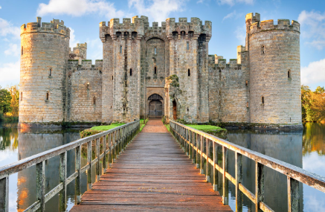  History – A Local History Study  Year 1 Autumn 1 2025 | P.S.H.E.  In PSHE this term, we are learning about ‘Me and My Relationships’.  Here is the link for you to access activities at home: https://www.coramlifeeducation.org.uk/family-scarf/scarf-at-home/me-and-my-relationships  R.E. -  This term in RE, we will be exploring the question “How did the world begin?” by looking at a range of beliefs and teachings from different religions and worldviews. Children will learn about various creation stories and scientific perspectives, developing an understanding that people hold different beliefs about the origins of the world.
PE  In PE we will be learning invasion games and FUNdamentals.  Music  In music, we will be learning the different instruments of the orchestra. We will also learn what pitch, pulse and rhythm is. | D.T- with Mrs Argent  As Year 1 designers we will be:  - Designing and making a simple logo design that represents the things you love about where you live.  We will achieve this by:  - Investigating badges and logos  - Exploring suitable resources to use | Computing  In Computing we will learning computing systems and networks.

