English  As writers we will:  - Write a story recount using the video stimulus ‘Caterpiller shoes’.  - Write the life cycle of a butterfly.  - Write a poem about nature.  As readers we will:  - Read books about famous women and men in history and develop our comprehension skills  - Read a variety of high-quality texts to improve our reading comprehension.  - Continue to focus on our set 3 phonics sounds | Maths  Addition and subtraction  Add to 20  Doubles and near doubles  Subtract within 20  Finding the difference  Counting back and forth within 20 from any number  Solve missing number problems  Place Value  - Count from 20 to 50  - 20, 30, 40 and 50  - Count by making groups of tens  - Groups of tens and ones  - Partition into tens and ones  - The number line to 50  - Estimate on a number line to 50  - 1 more, 1 less  Length and Height  - Compare heights and lengths  - Measure lengths using objects  - Measure length in centimetres | Science- Term 3 & 4  As scientists we continue to learn about plants and animals  - Understanding humans are animals  - Naming different parts on the outside of the human body and talking about what jobs they do.  - Explaining which parts of the human body we use for our five senses  - Understanding the life cycle of a human  - Learning the key features and functions of a plant  - Understanding why some plants are healthier than others  - Understanding the life cycle of a butterfly  - To recap the seasons and observe the changes in our environment from last term
History  As historians:  This term we will continue to answer our enquiry question:  How did Florence Nightingale, Mary Seacole, Alexander Fleming, Crick, Watson, Franklin and Sarah Gilbert change the world?  To achieve this we will:  - To compare the lives and achievements of Florence Nightingale and Mary Seacole’s .  - To know that women were treated differently compared to men in the past.  - Compare the responses of achievements of 2 women in history. | Year 1 - Spring 2  2026  The Greatest Britons  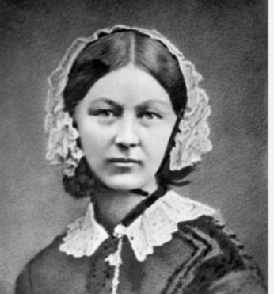 | P.S.H.E.  In PSHE this term, we are focusing on rights and respect.  R.E.  We will answer our inquiry question ‘What is God's job?’  Taught by Mrs Argent  P.E.  We will be learning dance alongside net and wall games.  Both lessons will be taught by Sports4All
Geography  As geographers this half term we will continue to:  - Locate countries in Europe (linked to historians).  - Locating Jamaica (Mary Seacole history links).  - Use a map to find locations in the UK.  - Recap continents of the world. | DT  As designers we will:  Be recycling an old sock to make a sock puppet. | Computing  As computer scientists we will be focusing on data information and grouping data.

