English  As readers and writers we will:  - Read ‘An Alien in a Jam Factory’  - Read a range of extracts linked to our rainforest topic  - Write a non-chronological report about rainforest animals  - Write a setting description of the rainforest  - Write letters to help the rainforest  - Use the Read, Write, Inc spelling program  - Learn the Year 3 SPaG objectives as part of our writing journeys. | Maths  As mathematicians, we will continue to learn about multiplication and division leading upto a focus on our 2, 10 and 5 times tables and explore length and height.  Multiplication and division  Arrays  Grouping and sharing  Odd and even numbers  The 2, 10 and 5 times tables  Dividing by 2, 10 and 5  Length and height  Measuring in cm and m  Comparing and ordering length and height | Science  As scientists, we will be learning about plants and animals  This half term we will:  - Learn about plant growth  - Investigate what plants need to survive  - Make scientific observations  - Learn about the life cycles of different animals  - Compare what humans need to be healthy with other animals
History  As historians, we will continue learning about explorers.  This half term we will:  - Find out about Sir Walter Raleigh  - Learn how explorers travelled and navigated in the past | Year 2 - Spring 2  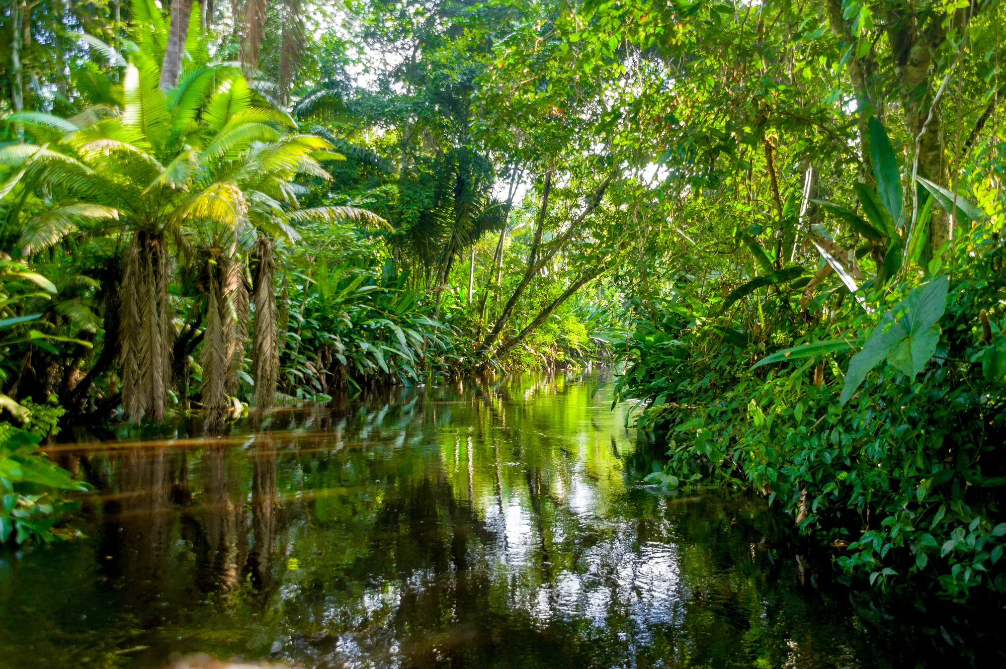  The Great Rainforests | P.S.H.E.  In PSHE this term, we are focusing on rights and repect  R.E.  Our RE question this term is 'What is a prophet?’  P.E.  We will continue to be taught P.E. by S4A. We will be focusing on dance and net and wall games.
Geography  As geographers:  This half term we will:  - Learn about deforestation and its impact | DT  As designers:  This half term we will be designing and making a tropical fruit smoothie. | Music  Our topic is ‘Music around the world through folk.’  Computing  As computer scientists we will be learning about data and information including how this can be collected and presented.

